Centralized Voting System using FDR & OTP
Submitted in partial fulfillment of the requirements of the degree of

“Bachelor of Computer Engineering”

by

(Roll No.: 23) Rohan Nikam (Roll No.: 10) Rohan Gaonkar (Roll No.: 15) Rohit Kannojia

Supervisor(s):

(Hasib Shaikh)


DEPARTMENT OF COMPUTER ENGINEERING

K.C.COLLEGE OF ENGINEERING & MANAGEMENT STUDIES & RESEARCH, THANE (E)
(2019-20)

CERTIFICATE

This is to certify that the project entitled “Centralized Voting System using FDR & OTP” is a bonafide work of “(23) Rohan Nikam, (10) Rohan Gaonkar ,(15) Rohit Kannojia” submitted to the University of Mumbai in partial fulfillment of the requirement for the award of the degree of “Bachelor of Computer Engineering"

Mr. Hasib Shaikh
Supervisor/Guide

Mr. Mandar Ganjapurkar Dr. Vilas Nitnaware
Head of Department Principal

ACKNOWLEDGEMENT

We would like to express special thanks of gratitude to our guide Mr. Hasib Shaikh as well as our Project Coordinator Mrs. Pragati Chandankhede and Mrs. Sulochana Madachane who gave us the golden opportunity to do this wonderful project on the topic of Centralized Voting System using FDR and OTP , which also helped us in doing a lot of research and we came to know about so many new things. We would also like to thank our principal Dr. Vilas Nitnaware for providing us the opportunity to implement our project. We are really thankful to them. Finally we would also like to thank our parents and friends who helped us a lot in finalizing this project within the limited time frame.

(Name of student and Roll No.)

- (Roll No.: 23) Rohan Nikam
- (Roll No.: 10) Rohan Gaonkar
- (Roll No.: 15) Rohit Kannojia

i

Project Report Approval for B.E.

This project report entitled Centralized Voting System using FDR and OTP by Rohan Nikam, Rohan Gaonkar, Rohit Kannojia is approved for the degree of Bachelor of Engineering in Computer Engineering.

Examiners

1.---------------------------------------

2.---------------------------------------

Date:

Place:

ii

ABSTRACT
Elections are fundamental pillar of a democratic system enabling the general public to express their views in the form of a vote. Due to their significance to our society, the election process should be transparent and reliable so as to ensure participants of its credibility. In this application, two authentication techniques are performed. Face Detection and Recognition (FDR), and One Time Password (OTP).In Face Detection and Recognition the voter’s image is captured and passed to a face detection algorithm which is used to detect his face from the image and save it as the first matching point. When user tries to log in, One Time Password provide for verify user. This OTP will be send to voter’s mobile phone. An OTP is a password that is only valid for single login session thus improving the security.
This desktop application contains two sides. One is admin side and another is user side. If the user is first time used this application then they need to register this application and fill the required information asked by this application. After successfully registration user can used this application. When its time to vote, user can get access from the admin. User can receive OTP for verification. After that user can cast their vote. In admin side, admin can give access to register user. After that admin can scan user face and give access to the user. Admin can provide OTP for verification to the user. After that user can cast vote. Admin need to add security question for each user and verify them.

iii

TABLE OF CONTENT
Sr.No. Topic Page No.
Acknowledgement i
Approval Sheet ii
Abstract iii
Table of Content iv
List of Figures v
List of Tables vi
Declaration vii
- Introduction 1
- Review of Literature 2
- Report on Present Investigation
  - Requirement Analysis 3
- Scope 3
- Feasibility Study 3
- Hardware & Software Requirement 3
  - Problem Statement 4
  - Project Design… 5-9
  - Methodology 10
  - Implementation Plan
    - Semester VII 11
    - Semester VIII
- Conclusion 12
References… 13

iv

List of Figures

Sr. No | Name of figure | Page No.
1. | Class Diagram | 5
2. | Use Case Diagram | 6
3. | Sequence Diagram | 7
4. | Data Flow Diagram | 8-9

v

List of Tables

Sr. No | Name of figure | Page No.
1. | Review Literature | 2

Declaration

We declare that this written submission represents our ideas in our own words and where others' ideas or words have been included, we have adequately cited and referenced the original sources. We also declare that we have adhered to all principles of academic honesty and integrity and have not misrepresented or fabricated or falsified any idea/data/fact/source in my submission. We understand that any violation of the above will be cause for disciplinary action by the Institute and can also evoke penal action from the sources which have thus not been properly cited or from whom proper permission has not been taken when needed.

Name of student and Roll No. Signature

  - (Roll No.: 23) Rohan Nikam
  - (Roll No.: 10) Rohan Gaonkar
  - (Roll No.: 15) Rohit Kannojia

Date:

vii

Introduction

India is an egalitarian country. Indian government is of the people, for the people and by the people. Therefore, elections play an important role. The most important feature of a democracy includes that the people must have the right of citizenship to choose the ruler for their country, state or local area. Thus, electoral process that is election by voting is an important aspect. With the evolution of technology, various voting techniques have been implemented such as ballot machines, EVMs, Kiosks and so on.

However, currently many E-voting systems have also been introduced namely punch scan, optical scan, specialized voting Kiosks and so on. Online voting using internet is one of the methods that have emerged. This system has been developed so that the voters at different remote locations can vote during general elections in his/her country. Voters just need internet access.

With the advent of technology, mobile phones with programmable platforms have emerged. Also, latest technologies such as biometrics (thumb scans, iris scans and face recognition) can be used to assure security for the voter authentication. Using some of the above-mentioned techniques and technologies, an effort has been made to develop an E-voting system for a modern individual.

The two authentication techniques are Face Detection and Recognition and One Time Password(OTP). In Face Detection and Recognition, the voter‟s image is captured and passed to a face detection algorithm which is used to authenticate his face from the image and save it as the first matching point. In One Time Password principle produces pseudorandom password each time the user tries to log on. This OTP will be send to voter‟s mobile phone. An OTP is a password that is only valid for single login session thus improving the security.

1

Review of Literature
Sr.No  . | Year of Publishing | Author name | Paper name | Merits | Demerits
1 | Apr 2016 | Patil Rahul H., TarteBabita B., Wadekar Sapana S., Zurunge Bhakti S., Prof.  Phursule Rajesh | A Secure E-Voting System Using Face Recognition and Dactylogram | Time Complexity is more | Less understandability for users
2 | Apr 2015 | Madhumita Deshpande, Deepali Zambre, Prajakta Mandle, Komal Hankare, Kanchan Shelke | E-Voting System for Modern Individual | This Paper concisely explains  the design and working of the application, which delivers  remote voting ability, precision,  greater privacy, good interface  and reliability towards the entire electionprocess. | Less user applicability
3 | Mar 2017 | R.Sandhiya , D.Indumathy | Online Voting Using Face Recognition and Password Based Security System | The paper focuses on the  importance of careful design of  the user-interface devoted to the  use of wide range of users of  different level of expertise with using computers | Less user understandability
4 | Feb 2014 | Ayesha Shaikh, Bhavika Oswal, Divya Parekh, B.Y. Jani | E-voting Using One Time Password and Face Detection and Recognition | This paper give better understanding of online voting  systems through facial recognition and OTP | Less user understandability

2

Report on present investigation

Requirement Analysis

Scope

In this project, we have implemented face scan and one time password which is an innovative and helps for voting user using laptop or computer. This desktop application contains two sides. One is admin side and another is user side. If the user is first time used this application then they need to register this application and fill the required information asked by this application.
After successfully registration user can used this application. When its time to vote, user can get access from the admin. User can receive OTP for verification. After that user can cast their vote. In admin side, admin can give access to register user. After that admin can scan user face and give access to the user. Admin can provide OTP for verification to the user. After that user can cast vote. Admin need to add security question for each user and verify them.

Feasibility study

A voting system which is unhackable or which cannot be tampered. Using FDR and OTP based integrated networks to store and record votes which allows voting to be almost 90% secure and accurate as it is integrated. The system has a user friendly interface and can be used to run polls and elections with total security and low level of manipulation

Hardware and Software requirements

Hardware requirements:

  - Laptop or computer

  - Processor:-intel core i5

  - RAM:-8GB Software requirements:
  - Platform used:-Windows 10
  - Python

Problem Statement
Online Voting are simple, attractive and ease to use. It reduces manual efforts and bulk of information can be handled easily. But out of all these features there are some drawbacks with this system are, there can be paper-based voting, electronic voting machine. Voting is the major issue as the identification of the person is the most important issue. As they do not have mostly the identity proof rather than the voting card & the fake voting is done on the large scale.

To avoid this, the project should be developed in such a way that it will store the identity of the voters & at the time of voting this identity will be matched using the facial recognition system to avoid the fake voting. This application will capture the face of the voter and match with the existing faces in the stored databases. After the verification of the valid face identify, an OTP will be generated and send to the voters register mobile and then he will use that provided OTP and then only his validation is succeeded and allowed to vote.

4

Project Design
    - Class Diagram:-
- User class diagram:
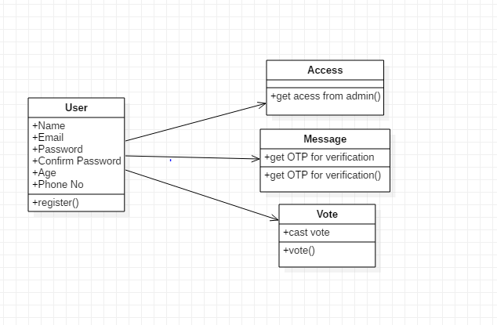
- Admin class diagram
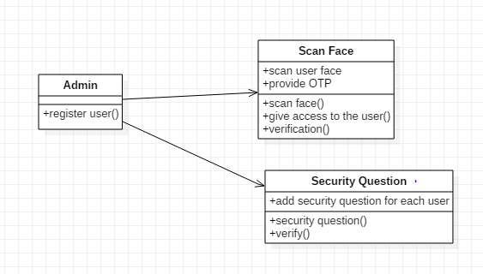
5

    - Use case diagram:-
- User UseCase diagram:
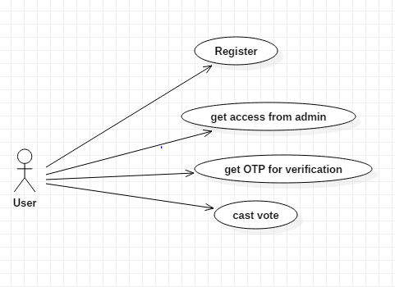
- Admin UseCase diagram:
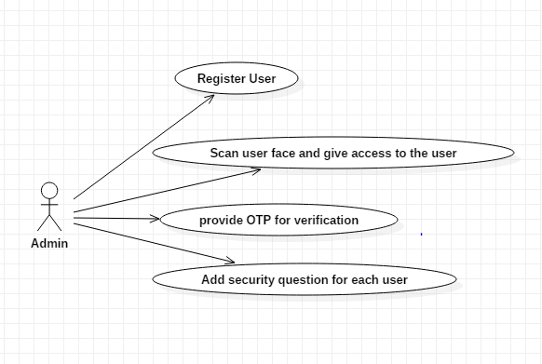

    - Sequence Diagram:-
- User sequence diagram
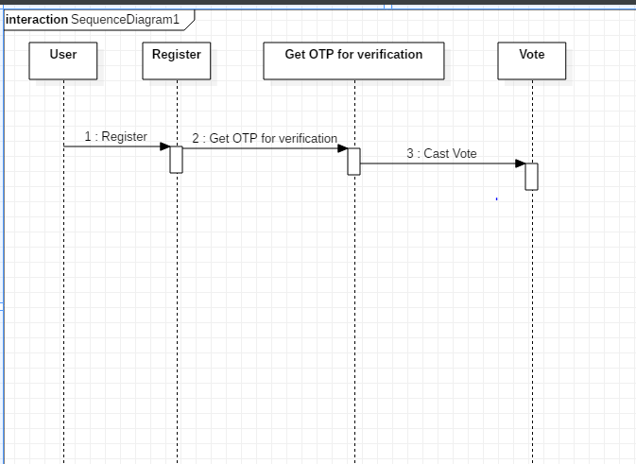

- Admin sequence diagram
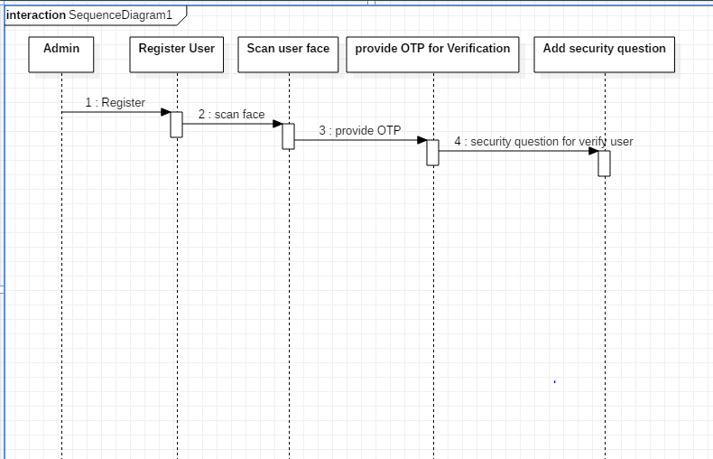

- Data flow diagram:-

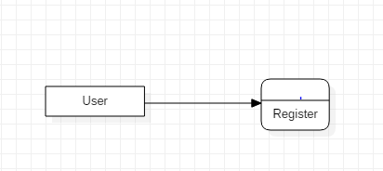
- User data flow diagram: Level 0:

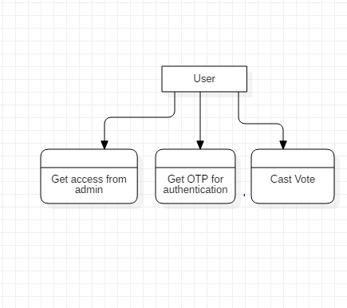
Level 1:

8

- Admin data flow diagram: Level 0:
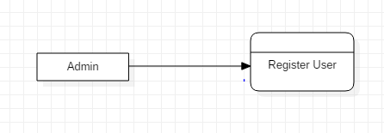
Level 1:
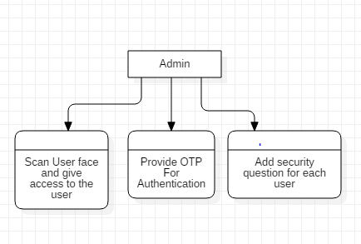

9

Methodology
In user side,if the user is first time used this application then they need to register this application and fill the required information asked by this application. After successfully registration user can used this application.When its time to vote, user can get access from the admin. User can receive OTP for verification. After that user can cast their vote.
In admin side, admin can accept user registration. After that admin can scan user face and give access to the user.In Face Detection and Recognition the voter’s image is captured and passed to a face detection algorithm which is used to detect user face from the image and save it as the first matching point. Admin can provide OTP for verification to the user. After that user can cast vote. Admin need to add security question for each user and verify them.An OTP is a password that is only valid for single login session thus improving the security. Admin can add security question for verify particular user

10

3.5.1 Semester VII

3.5 Implementation plan

Activity | Days | Start Date | End date
Guide meeting | 1d | 08/29/19 | 08/29/19
Title Conformation | 1d | 08/30/19 | 08/30/19
Research on Project | 10d | 09/07/19 | 09/17/19
Research gathering | 10d | 09/18/19 | 09/28/19

3.5.2 Semester VIII

4. Conclusion

The main advantage of project is simplicity which attracts lot of voting users. This application can easily used by the user. In this project, we have implemented face scan and one time password which is an innovative and helps for voting user using laptop or computer.
Face Detection and Recognition (FDR), and One Time Password (OTP).In Face Detection and Recognition the voter’s image is captured and passed to a face detection algorithm which is used to detect his face from the image and save it as the first matching point. When user tries to log in, One Time Password provide for verify user. This OTP will be send to voter’s mobile phone. An OTP is a password that is only valid for single login session thus improving the security.Security question is added to increase accuracy since FDR isn’t fully accurate.
This application saves the time of users. As the people uses computer so that the accuracy is increased. The major advantage of e-voting is user can cast the vote from any place and at any time with increased security.

12

Referencene

- Hari K. Prasad, J. Alex Haldermany, Rop Gonggrijp, Scott Wolchoky, Eric Wustrowy, Arun Kankipati, Sai Krishna
Sakhamuri, Vasavya Yagati, “Security Analysis of India’s Electronic Voting Machines”, April 29, 2010.
- Sheifali Gupta, O.P. Sahoo, Ajay Goel, Rupesh Gupta, “A New Optimized Approach to Face Recognition Using
EigenFaces”, Global Journal of Computer Science and Technology Vol. 10 Issue 1, April 2010.
- S. Ravi, S. Wilson, “Face Detection with Facial Features and Gender Classification Based on Support Vector Machine”, 2010
Special Issue - International Journal of Imaging Science and Engineering.
- Hemlata Sahu, Anupam Choudhray, “Polling System Using GSM Facility”, International Journal of Scientific & Engineering
Research. Volume 2, Issue 10, Oct-2011.
- Mr. Mayur Patil, Mr. Vijay Pimplodkar, Ms. Anuja R. Zade, Mr. Vinit Vibhute, Mr. Ratnakar Ghadge, “A Survey on Voting
System Techniques”, International Journal of Advanced Research in Computer Science and Software Engineering, Volume 3, Issue
1, January 2013 ISSN: 2277 128X.
- Feng-Li Lian, Yi-Chun Lin, Chien-Ting Kuo, and Jong-Hann Jean, “Voting- Based Motion Estimation for Real-Time Video
Transmission in Networked Mobile Camera Systems”, IEEE TRANSACTIONS ON INDUSTRIAL INFORMATICS, VOL. 9,
NO. 1, FEBRUARY 2013.

13

